Field Maintenance Rules

Daily Routine after Practice and Games, at the end of the day.
Drags must always be transported on the back of the Gator. Never drag from field to field behind the Gator.
Rake (fill) all holes, batter boxes, pitching rubber and catcher/umpire positions
Remove the bases and rake (fill) all low areas from sliding (DO NOT drag over the bases)
Rake loose dirt off grass along the infield edge
Drag the infield in an approved manner
Water the infield for at least 8 minutes or until puddles start to form
Dragging the Infields
Proper dragging technique will keep the infields level and safe for play. One of the most common mistakes grounds crews make is to drag the infield in the exact same pattern and direction every time. This creates inconsistencies and low/high spots in the playing surface. Make sure you change your dragging pattern/direction each time to keep low and high spots from forming.
Mat dragging, or leveling, is a similar process. Speed control (No faster than walking speed) is critical for a quality job. Proper speed will aid in cutting down high spots and filling low spots. Keep screen drags at least 21 inches away from all edges. These you should do by hand with a rake or a drag broom. Always rotate your starting and stopping points. Try to start on a high spot and end on a low area.
Never drag the dirt onto the grass when finishing
Never drag/play on a wet field, if raking by hand is not an acceptable alternative the game/practice will need to be moved or canceled.
Proper Dragging Technique
Always start from the outside and work towards the center being mindful that we want to pull dirt from the edges of the field towards the center (Never start in the center and work out!)
One of the best patterns is using overlapping circles as you go around the infield finishing with a circle in the center of the infield
Below are a couple other suggested patterns

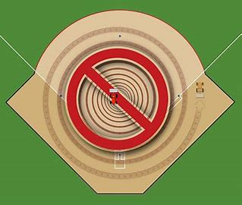

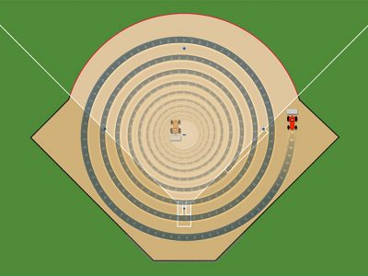
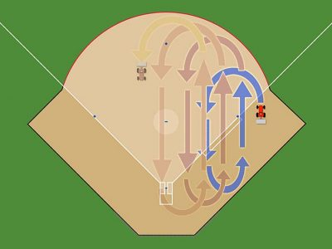

All Coaches are responsible for their field conditions, you will need to train your dad’s and other helpers to properly drag the infields. At the end of the day, when you leave, All fields will have all holes filled in, dragged and water. Failure to do so will result in loss of field use privileges

